**Configuring the SSL in Talend (TAC)**

Approval

| Signatures by each signatory indicate their acceptance that this document is complete and accurate to the best of his/her knowledge per responsibilities outlined in this document and as guided by approved methodologies and established procedures. | | |
| --- | --- | --- |
| Team Lead:  Artha Emp | **Subhransu** | **Date:** |
| Project Manager:  Artha Emp | **Pavan Valluri** | **Date:** |
| Talend Developer:  Artha Emp | **Omkar patil** | **Date:** |

(NOTE:- Ask the client for the .pfx file)

Step1: - cd /opt/Talend-8.0.1/tac/apache-tomcat/conf

Step2:- Generate the key using the command

keytool -genkey -keyalg RSA -alias tac-tomcat -keystore tac-tomcat-keystore.jks -storepass tacadmin -validity 3600 -keysize 2048

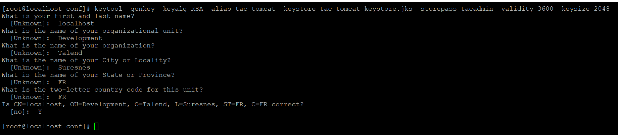

Step3: - Add the keystore certificate to Apache Tomcat truststore.

Password:- tacadmin

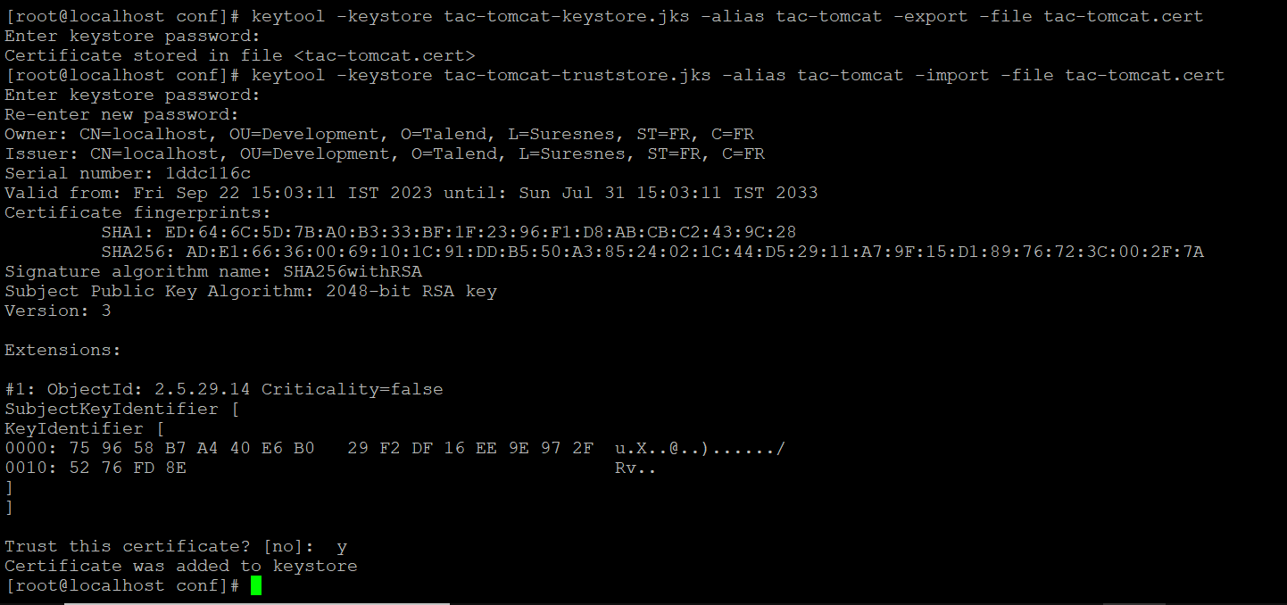



Step4: - Upload the certificate file to browser.

1. Open the **Internet Options** dialog in IE.
2. Select the **Content**tab.
3. Click the **Certificates**button
4. Import the **.cer** file created
5. **Trusted Root Certification Authorities**section.

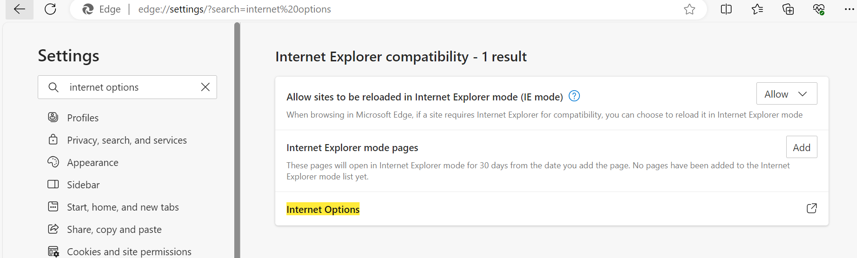

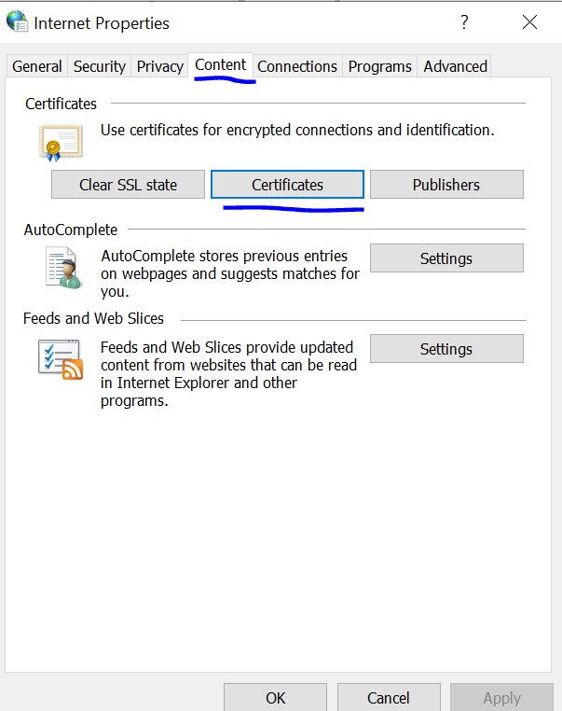

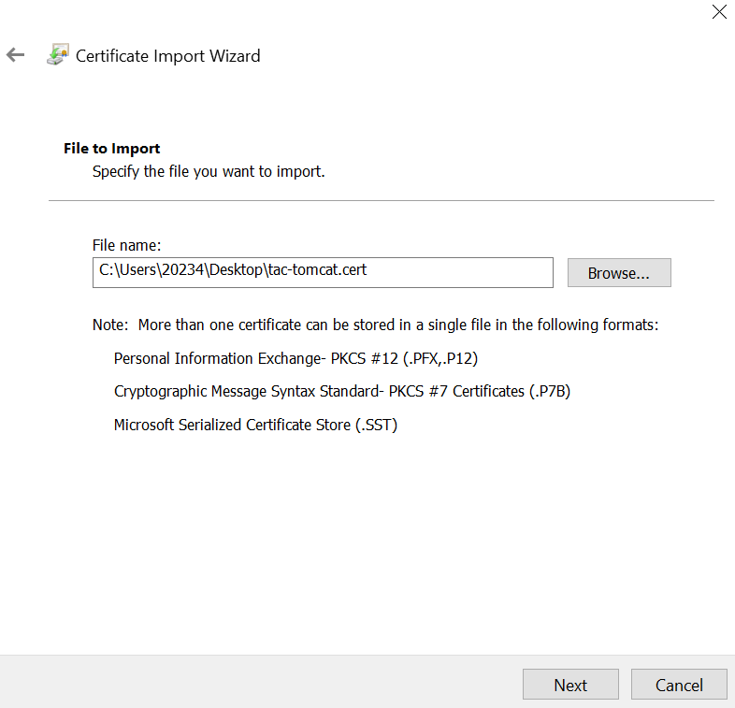

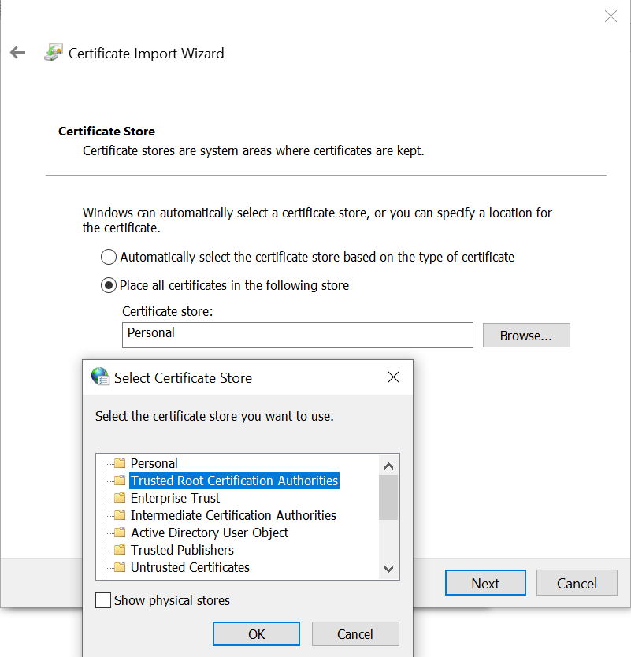

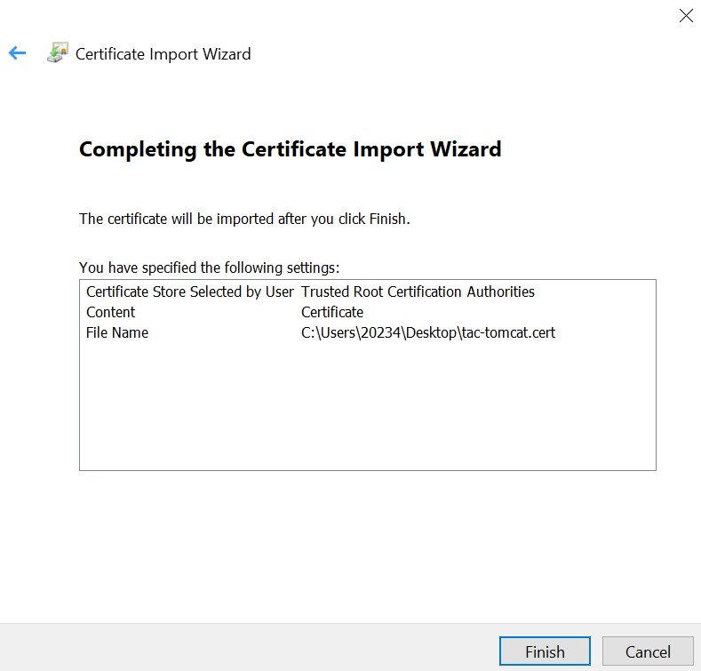

### Step6: - Tomcat Configuration

1. Shut down Tomcat.
2. Navigate to the Tomcat **conf** sub-folder.
3. Edit the **server.xml** file.
4. Locate and uncomment the SSL-enabled HTTP connector (it is commented out by default).
5. Modify the connector config* as follows:

<Connector port="8080" protocol="HTTP/1.1" SSLEnabled="true"

maxThreads="150" scheme="https" secure="true"

clientAuth="false" sslProtocol="TLS"

keystoreFile="*full path to keystore file from above*"

keystorePass="talend"/>

vi server.xml

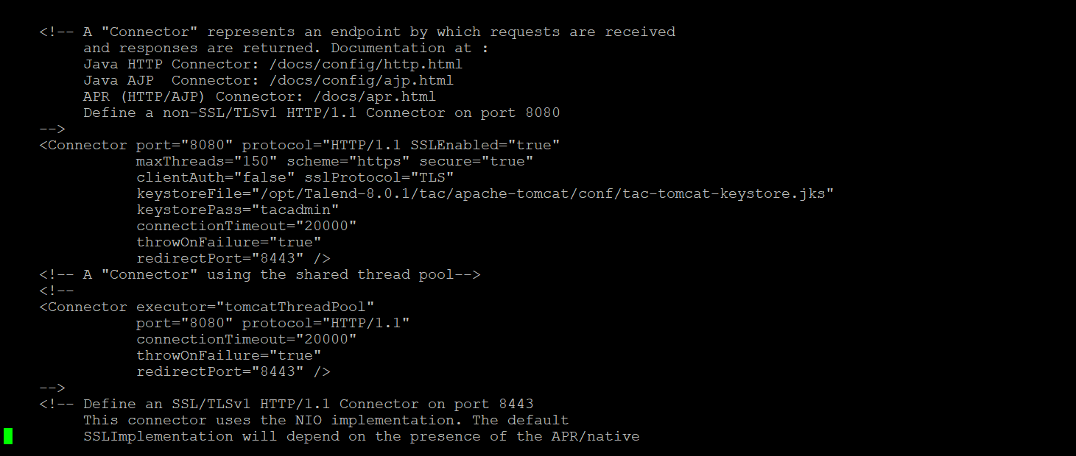

Step 7: - Restart service the Talend TAC

systemctl status talend-tac-8.0.1.service

systemctl restart talend-tac-8.0.1.service

Step8: - check the service on server

<https://192.168.1.179:8080/org.talend.administrator>

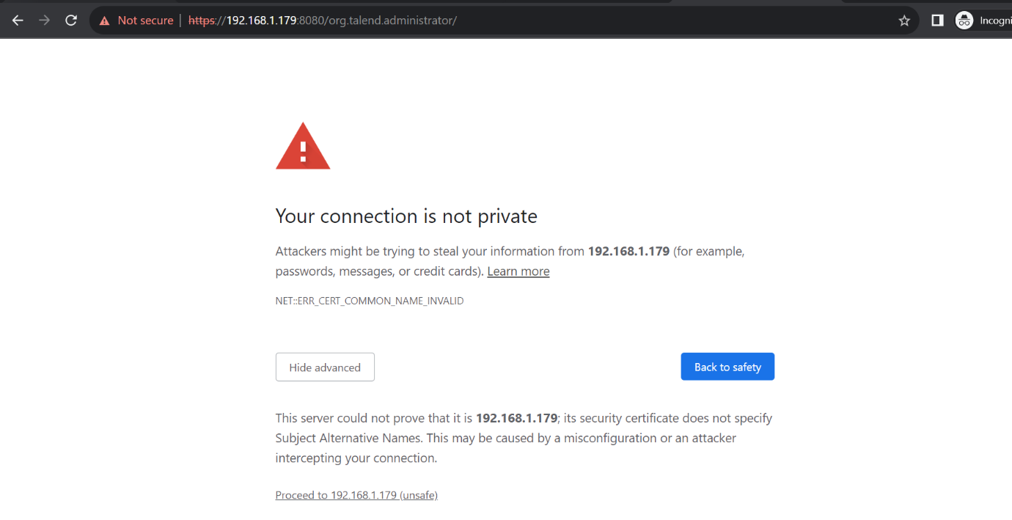

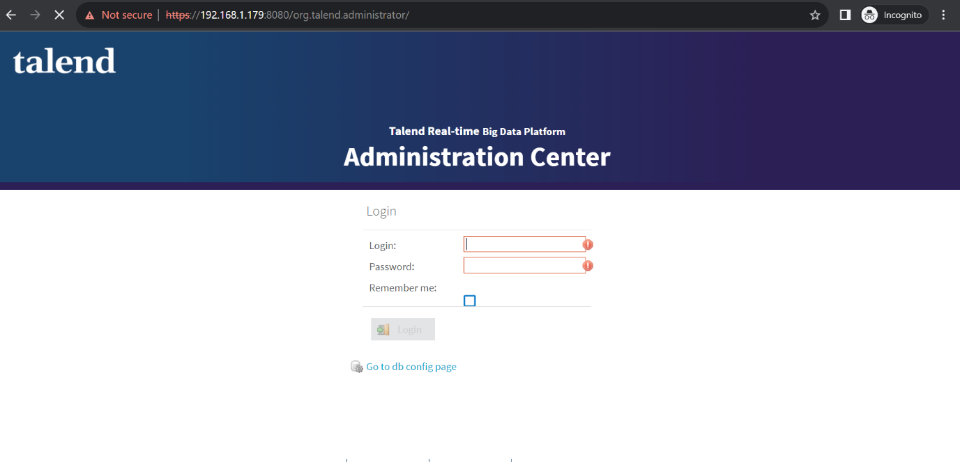

<https://help.talend.com/r/en-US/8.0/installation-guide-linux/config-ssl-for-tac>

<https://community.talend.com/s/article/How-to-configure-Talend-Services-to-use-SSL-UM3Wt?language=en_US>

#Upload certificate in google.

<https://www.wipo.int/pct-eservices/en/support/cert_import_backup_chrome.html>

Administrator